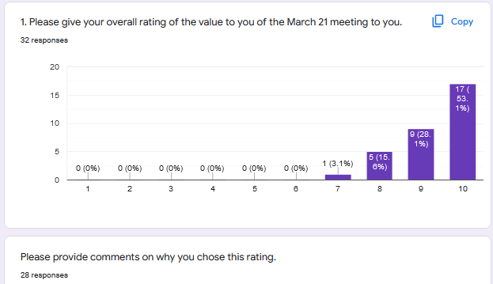

|  |  |  |
| --- | --- | --- |
| ID# | Value | Please provide comments on why you chose this rating. |
| 1 | 10 | well planned, ran smoothly, good small group, good idea not having reports |
| 2 | 10 | The preparation for the meeting was excellent as was the content. It is invaluable to have the kind of conversations we are having, in order for CCA to move into the future. |
| 3 | 10 | Presentations were excellent, it was well run and it ended on time! |
| 4 | 9 | it was great - my only regret was the lack of time to dive into deeper waters |
| 5 | 8 |  |
| 6 | 10 | Great to be together talking and sharing about CCA |
| 7 | 10 | It gave me some sense of the way other communities are exploring and experimenting with other models of being Carmelite |
| 8 | 8 | Information was helpful. It's good for the sisters to be together. |
| 9 | 10 | It has been helpful to share on Zoom |
| 10 | 8 | Meeting was good as always but we did not get to the last 3 questions which I felt were the more interesting ones! |
| 11 | 10 | I thought it ran well and the sisters were enthusiastic in participating. Some good ideas for generating new life in communities were presented in my small group. |
| 12 | 9 | It is always good to share and be present to each other even by ZOOM. |
| 13 | 9 |  |
| 14 | 10 | The meeting was well planned and focused on new life. I appreciate that so many sisters partivipated |
| 15 | 10 |  |
| 16 | 10 | It was a great opportunity for sharing and getting to know our CCA communities better. |
| 18 | 10 | It is life-giving to be together and to share with one another. |
| 19 | 9 | I would have liked a little more time to cover all the questions in the small groups. Otherwise, the sharing was excellent |
| 20 | 10 | The good attendance, the interest & thoughtful contributions of the sisters, quality of participation, the ideas that were generated. |
| 21 | 10 | honest, kind sharing of important issues and achievements, as well as losses |
| 22 | 9 | The sincerity of interest, insights, concerns of each other and for Carmel is inspiring and comforting. |
| 23 | 10 | Well noticed in advance about what we would discuss and well organized. |
| 24 | 10 | it is crucial to keep in touch with each other |
| 25 | 10 |  |
| 26 | 8 | I think we would be OK with 1 question to answer, 2 at most . |
| 27 | 9 | It's always nice to see and hear from our sisters even if it's just through virtually. |
| 28 | 9 | I thought it brought out that we are all in the same predicament, even those who are currently getting vocations. |
| 29 | 9 | The value of the meeting was in being with the sisters, listening to the experiences of the communities and their reflections on them. Much of what others are doing cannot apply to our community at present. It is hard to understand and discern where CCA will be going in the near future, and how we all need to be doing it together from our own experiences. |
| 30 | 9 | I found the exchanges very life-giving. |
| 31 | 8 | Not enough time for group sharing. Would like short prayer, reflection at the very end of the meeting. |
| 32 | 10 | It is a great help to us who are no longer at our monastery to be able to see you and to share with you. I am wondering if, as we proceed together, we might be able to explore some way or ways to help our communities who may have to face the closure of their homes. |
| 33 | 7 | I was in and out during the meeting. Had trouble with my computer and attended most of the meeting on my phone (!) had to run to answer the door and missed my turn to speak - I was a disaster! And I'm afraid I missed parts of the meeting. |

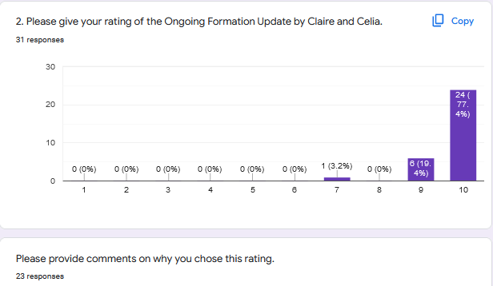

|  |  |  |  |
| --- | --- | --- | --- |
| ID# | FormatorsTalk | Please provide comments on why you chose this rating. | If you have any ideas/recommendations for the Ongoing Formation Team please provide: |
| 1 | 10 | clear informative presentation |  |
| 2 | 10 | The content is wonderful and it is essential for us to stay connected. I am especially grateful for the international connections and for Liz S and for we space. |  |
| 3 | 10 |  |  |
| 4 | 10 | Two highly organized people who are sensitive to diverse interests - great team |  |
| 5 | 9 | Claire and Celia were clear as to what they are offering = they were open and enthusiastic about their response to the Nuns' desires | I would like to hear about and new ideas or plans that our CCA communities have tried = are trying = hasn't worked - to revitalize our life and attract new members - maybe a brainstorming session together |
| 6 | 10 | Great work by Claire and Celia. Thanks for keeping us posted. |  |
| 7 | 10 | There answers were clear; they scoped out an outline of where formation progrgms are going |  |
| 8 | 10 | They are clear in goals. | Good to organize all CCA's endeavors well so folks don't get overwhelmed. |
| 9 | 9 | I am grateful for your work and impute. | Keep doing as you are with additional inputs as inspiration leads.. |
| 10 | 10 | I feel Claire and Celia are doing a wonderful job. There is something on offer for all. |  |
| 11 | 10 | It was interesting to hear how they work together and with the leadership team to put together the programs they present. They are a real asset to the association. | I think it is very good that we continue to build relationships with the international sisters. However, I would also hope that we could share some programs with the other US Associations to begin rebuilding the working relationships we had with them in 2018. |
| 12 | 10 | BRAVO ! They are doing and excellent job. |  |
| 13 | 10 |  |  |
| 14 | 10 | All that this committee has done has been excellent. |  |
| 15 | 9 |  |  |
| 16 | 10 | I learned more about the time involved in all that they are doing for us - I am grateful for the opportunities that Claire and Celia have offered us. |  |
| 18 | 10 |  |  |
| 19 | 10 |  | Just want to say that Iâ€™m really looking forward to the input from Daniel. So, great choice! |
| 20 | 10 | Claire, Celia (& JonFe as thought partner) have worked hard and given much time, and are fully committed to CCA and ongoing formation for the association. They reflect positive energy! | Right now I can't think of any new initiative (perhaps when we finish this year's WWD & We Space). I encourage them to keep making known & reminding us of what is available through RFC, NRVC and other places. |
| 21 | 10 | positive, open information about formation process, realistic | keep on going and thank you for your service to us all |
| 22 | 10 | It is amazing all that they are doing for us - the work and energy involved is remarkable . I am truly grateful. | Topics and speakers are great - But maybe to keep our link to scripture - it being our rootedness - upfront and center might be given more attention |
| 23 | 10 |  | Thanks so much to them for their hard works for CCA |
| 24 | 10 | Thank you for all the work you are putting into this. I thoroughly the course we were able to participate in with Queen of Carmel given by Mary Pat Garvin, RSM. |  |
| 25 | 10 |  |  |
| 26 | 10 |  |  |
| 27 | 9 | I greatly appreciate what Claire and Celia is doing for the Ongoing Formation, I know it's not easy. | Would be nice to have more talks/discussions with Carmelite friars/brothers and sisters from other Carmels to share their perspectives of what Carmel is today and how each respond to its challenges. |
| 28 | 7 |  |  |
| 29 | 10 | I value highly what the Association Formators have been doing for us. It has really made such a positive difference in our community and our personal lives. | Continue to take advantage of what comes up or presents itself, as you did for the synodal gatherings. If you ae not sure how much interest a possible idea would have, do not hesitate to ask us. I do not have any specific recommendations for future programs, but perhaps communities who have many resources for education, etc. could suggest some. |
| 30 | 9 | They have kept us very well informed, and obviously have put a great deal of work and care into all they have done. |  |
| 31 | 10 | I wasn't aware before that Claire & Celia were the ones working on "on going formation". It has been so good for me to participate in these sessions. Unfortunately, anything held on Tuesday afternoon (which seems to be many events) I cannot attend, due to a previous long term weekly commitment. Any other day of the week is fine only Tuesday afternoons are not free for me. | Brainstorming about our future as it seems more communities maybe on verge of closing. How can we create places, spaces where displaced sisters can still gather and continue to live our OCD charism? |
| 32 |  | Theresa and I had previous engagements. We could not be present for this section. |  |
| 33 | 9 | I haven't participated in all the input sessions but those I did, I enjoyed and learned from (synodality and some of the book club with Maria Cimperman). Very eager to participate in Dan Chowning's lectures. Grateful for all that has gone into Claire and Celia's work. | More on our history, saints, Rule, spirituality of the order in general (these interest me more than methods of prayer) |

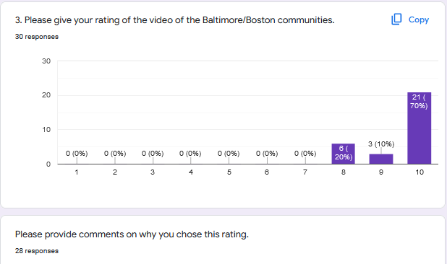

|  |  |  |
| --- | --- | --- |
| ID# | Video | Please provide comments on why you chose this rating. |
| 1 | 10 | The questions were good and the sisters did a good job of responding to them. |
| 2 | 10 | The clarity and the honesty. |
| 3 | 10 | Both presentations were informative, inclusive of different community members and well presented. |
| 4 | 10 | presentation included members of community - well done |
| 5 | 9 | As I am from Baltimore (and of course, love what we are doing!)=I will speak only of Boston's report - I liked the way they involved a number of Sisters and introduced us to their new members -they were clear as to what they are doing and seemed hopeful about their future. I would have liked to hear more about their experience with younger women who have expressed interest in their life |
| 6 | 10 | Boston was a little more organized in answering the questions - but good overall |
| 7 | 10 | I think it gave us a good sense of where Boston is and how they are thinking. [I already know how B-more is thinking. :-) ] |
| 8 | 9 | They were both interesting and informative. |
| 9 | 10 | It is helpful to get to know other Carmels in our Association. |
| 10 | 8 |  |
| 11 | 10 | Their sharing of how their communities are attracting vocations and generating new life were informative and it was interesting to note the differences and similarities between the two communities. |
| 12 | 10 | Both communities had prepared thoughtful presentations and covered aspects of emerging new life is their respective communities. |
| 13 | 10 |  |
| 14 | 10 | I appreciated that a number of sisters shared what is happening in Baltimore and Boston. It was very helpful to hear the experiences. New ideas came to me from this presentation |
| 15 | 10 | it is good to learn the impact of culture on young women of today |
| 16 | 10 | I learned new things about both of these communities and am grateful for all that was shared. |
| 18 | 10 | Both communities did a beautiful job and provided helpful information. |
| 19 | 10 | Learning from each other is always a blessing |
| 20 | 10 | Each community's sharing reflected the time, planning, thought and commitment the community has give to attracting new members, the initial formation program, and even post-profession formation (e.g. Celia's studies at Villanova). The whole community is involved and takes responsibility for the new members who enter. |
| 21 | 10 | good work |
| 22 | 9 | It is good when several members in a community speak from their experience |
| 23 | 10 | Thanks for the informative presentation of Baltimore community! |
| 24 | 8 | I liked how Boston involved everyone in their video. I am from Baltimore, won't comment. |
| 25 | 10 |  |
| 26 | 10 |  |
| 27 | 8 | There were some parts that needs editing. |
| 28 | 8 | I'm grateful to hear the status of each community in detail, and especially their experience with new candidates. |
| 29 | 10 | They were both clear, well -presented, hopeful, realistic , and just generally uplifting. I am so glad they were willing to share. |
| 30 |  | Something went askew with my computer reception at the start of the reports which really messed them up. But I'm sure they were very good |
| 31 | 8 | Both were well presented. I liked that they involved so many of the different sisters within their communities to speak. |
| 32 |  | We missed this also. Perhaps at a later date or in some way we might be able to see it. |
| 33 | 8 | Very interesting input! Creative ideas. |

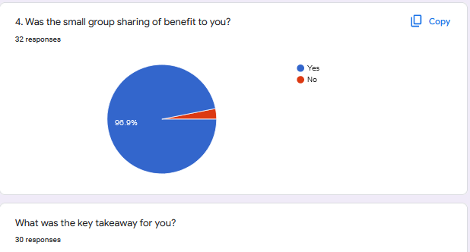

|  |  |  |  |
| --- | --- | --- | --- |
| ID# | Sm Grp | What was the key takeaway for you? | What recommendation, raised in your group, that should be shared with the LT? |
| 1 | Yes | Whether or not the communities are still accepting newcomers, there is much that has been lifegiving for them, and they are still vital. | N/A--the discussion wasn't geared toward coming to a recommendation. |
| 2 | Yes | That our communities are open to new ways and new experiences and fine this time life giving |  |
| 3 | Yes | Less autonomy, more connections! We need to stay connected and collaborate as much as possible within the Association, between US Associations and internationally. | Have newer members meet together for support - if possible - in person; if not - on ZOOM. Encourage shared participation in formation opportunities between our monasteries and outside the monastery with groups of other newer members in Carmel or with Apostolic sisters. If communities need funding for this - could CCA offer support?  Consider inter-community visits (national and international) now that COVID has subsided (at least for now) to strengthen our bonds and look to the future. |
| 4 | Yes | Hope that 'together' we walk into the future | Today's topic deserves a second session - focusing on the value of including all sisters in support of each other - mtg to discern how/ |
| 5 | No | The small group I was in was rather ineffective I am sorry to say - a good deal of repetition of old problems - no enthusiasm on the part of some- no dreams of what could be - seemingly no enthusiasm for what IS being tried - | I don't believe so. |
| 6 | Yes | We just need to be together to talk about what is going on with us | Can a "younger" sister (not necessarily in initial formation) be set up to companion a sister in a nursing home or outside of a community situation.  Can someone "younger" interview the older sisters, or can we have a forum where sisters share their stories so they do not get lost. |
| 7 | Yes | What other folks are doing can seed new ideas for me. It is important to be bold in our 'futuring' | As Covid subsides, let's set up sisterly visiting [not sisterly visits] with other communities, especially transnationally. Lets continue providing ways for the newer members to meet together and bond. |
| 8 | Yes | There's a lot of life despite change, etc. |  |
| 9 | Yes | Connection | Zoom meetings are helpful especially for those more isolated. |
| 10 | Yes | All in my group seemed realistic and engaging with the realities of where we are now as well as able to deal with diversity and unknowingness. | None |
| 11 | Yes | "New Life" does not have to mean only new members. It means recognizing and dealing with the realities a community is facing in a way that fosters a spirit of "newness" even in the sameness of living our charism daily. Efforts to constantly renew, enliven and share our life, provides incentive for new people to come. Communities with new members find themselves having to face the joys and problems of passing on the charism to someone new. Even if the new member doesn't persevere, it brings newness of life to the Community. Communities who have not had new members for awhile or do not see themselves as able to take new members have to decide "how and if" they are willing to foster a "newness of life" within their community. Some communities have realized this "newness or life" by sharing the charism beyond their own monastery (either in person or thru technology), undertaking new living arrangements that have opened them to new experiences, or developed new practices that allow for personal and communal growth. |  |
| 12 | Yes | Each community is different and they are responding to their needs with creativity and insight. |  |
| 13 | Yes |  |  |
| 14 | Yes | Be present to the reality of the moment. Leave space for the new to enter | We need to continue to connect |
| 15 | Yes | educate the FRIARS so that we continue on the same  how can we assist CARMELS FACING CLOSURE  need to prepare for the ageing of our sisters  welcoming of transfers fro another carmel is not easy process and demands detchment from non essentials | let us gather the stories from our "elders" |
| 16 | Yes | Our communities may be very different especially in the area of outreach, but for everyone there is wisdom in living one day at a time, trusting in God's faithful love and guidance. | that more be done for sisters in Carmels that have closed who do not have the support of community life. |
| 18 | Yes | There is new life. The future is uncertain. |  |
| 19 | Yes | It would be a blessing to somehow incorporate our sisters whoâ€™s monasteries have been closed into the initial formation experiences of new members. They have wisdom to share. They have lived, and are living through, tremendous spiritual challenges as they remain faithful to their vocation in uncharted circumstances. How much they could witness to fidelity and the whole Paschal Mystery! | See above |
| 20 | Yes | New life to our communities comes in many forms, not only through entrance of new members. Important to think of the future of Carmel and not just one's individual monastery. One way to support communities who attract and accept new members is financial.   Communities whose profile make it unlikely that they could sustain a new member through the initial formation program (e.g. lack of trained formation personnel, lack of a formation program, have not had a new person in many years, etc.), could discern with women who inquire and refer potential candidates to a Carmel that has new vocations. Even though open to transfers, it is important to balance one's community profile (e.g. age, health, vitality) with the person seeking to transfer (e.g. her age, physical/emotional health, positive contribution to community, reasons why the person is seeking transfer). | In our desire to attract and accept new members, it is important for a community to do an honest assessment of the life & health of the community, to be open and accepting of its reality. It would be unfair to bring a new member into the community if supports are not in place to sustain her through the entire formation process. |
| 21 | Yes | that we are all very lovingly concerned for our Carmels, and for their needs and issues | keep this type of meeting going from time to time. It helps us all |
| 22 | Yes | commitment and concern for Carmel lies deep within and waiting for its springtime - again. "Again" is a good sign because it assumes new life and relevance in today's world. It is also a wonderful gift to be more actively and directly bonding with our Sisters internationally. |  |
| 23 | Yes | All we struggle to keep up the life of Carmel, of the Spirit of Carmel and the desire itself is beautiful, we are connected in the holy desire and the reality. |  |
| 24 | Yes | Vocations are not the only way to have new life in your community. Totally agree. | Newer people visiting Carrmels whether or not they have vocations.  Different ways of having new life, e.g. planning for the future, pets were both mentioned. |
| 25 | Yes |  |  |
| 26 | Yes | We want to -and do - support one another. |  |
| 27 | Yes | As Carmelites, we can always see or experience new life emerging even in simple things and events. | Those Carmels who are not capable to accept aspirants for formation can still journey/discern with them, then if they think the aspirant have a vocation, they can recommend them to a Carmel where they think the aspirant is suitable. |
| 28 | Yes | It is getting easier to share on Zoom. There was mention of getting rid of "patriarchy" in the Church and mentioning our Friars. It has not been my experience and would like not know more. |  |
| 29 | Yes | Our communities include a wide range of experiences at this time. It is important for CCA, both leadership and members, to have opportunities to listen and understand one another. | A real and general openness to accepting transfer sisters in the communities in our group, except for one. |
| 30 | Yes | the need to find ways of involving in the life of CCA those living apart from community not by choice | That the slide presentation that Marian of Barrington has should be put on video and shared. |
| 31 | Yes | We have much to share w/each other. Ques 5 was scary and even communities with newer members realize that in several years without more newer & lasting members joining them they will not continue to survive as a viable Carmelite Monastery. | It is good to reach out and share more in practical ways with other Carmelite communities (nuns & friars) nationality and internationality, perhaps spend time at another monastery and get to know each other as we grow smaller in numbers. |
| 32 | Yes | The new life in monasteries of our small group. |  |
| 33 | Yes | I love being with the group and sharing; did not do as much as I had hoped but that could not really be helped. I'm just sorry I was such a non-entity in the group! |  |

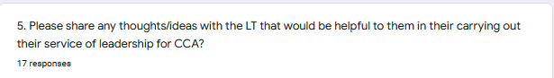

|  |  |
| --- | --- |
| ID# | 5. Please share any thoughts/ideas with the LT that would be helpful to them in their carrying out their service of leadership for CCA? |
| 1 |  |
| 2 | Just keep doing what you are doing!!!! |
| 3 | Consider hosting a facilitated, inter-generational exchange about expectations our older religious have on newer members and newer members have on our religious communities. What are they looking for today to support their spiritual journey? Are they finding it in Carmel? Are there ways we need to adapt to the mentality that the younger generations bring? |
| 4 | Thank you for the energy given to this projects - creates community |
| 5 | You are doing a great job of keeping us connected, and for that I am deepky grateful. |
| 6 |  |
| 7 |  |
| 8 |  |
| 9 | You're doing great. Thank you all. |
| 10 | I hope they will continue to refer to, emphasize, what the Collaborative can do for us. This is one of the best things that has happened for CCA. |
| 11 |  |
| 12 |  |
| 13 |  |
| 14 | I think either LCWR or RCRI have people to help with grief. Maybe it could help those who are struggling. Continue to have meeting that are life-giving like this one |
| 15 | keep all communities involved |
| 16 | Please know how much we appreciate you and your service to CCA. |
| 18 |  |
| 19 |  |
| 20 | Encourage the LT to make contacts and share information & resources with the communities that can be helpful in discerning a community's situation and outlook for the future. The LT can encourage communities to be proactive in seeking solutions and life-giving options before a community is faced with having to make choices out of desperation. Encourage the LT to begin a process within CCA to look at our governance & new models. LT be responsible for forming a CCA task force to implement and carry forth this process, leading up to our next general assembly. Possibly the task force, or another small group working with the LT and task force, can manage our upcoming national meeting? |
| 21 | none at present |
| 22 | Keep on keeping on - but be careful of your health and energy levels |
| 23 |  |
| 24 | I believe we need to discuss what could be CCA's future, especially if communities continue to go under CCA leadership. Is there a number of autonomous communities that are needed to make an association? What about an international association? This has been mentioned before. I don't want us to get caught with our pants down!!! Maybe we could have a subgroup discussing this, just typing out loud. |
| 25 |  |
| 26 |  |
| 27 | You're doing great, given the challenges of our situation right now. |
| 28 | With all we have to do in our community, there is a plethora of meetings going on now. This causes many to feel they don't have the time to participate. We might rethink about prioritizing what we meet about and seeing if we could do with fewer meetings. I love them but there is only so much time... |
| 29 |  |
| 30 |  |
| 31 | Thank you so much to each of you for the immense amount of thought, prayer, planning and time that goes into organizing these meetings! |
| 32 | Thank you for all you are doing. |
| 33 |  |

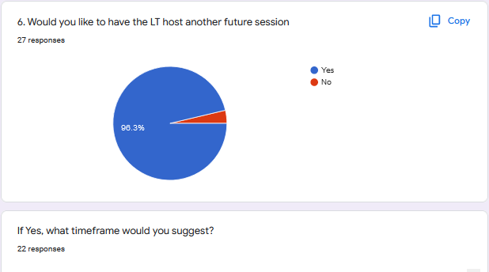

|  |  |  |  |
| --- | --- | --- | --- |
| ID# | MTG | If Yes, what timeframe would you suggest? | What would you like covered at such sessions |
| 1 | Yes | 2 per year, approximately six months apart | Part of the purpose is getting together to share. The issue will emerge. |
| 2 | Yes | End of summer | I think it is too soon to determine that - life changes so quickly |
| 3 | Yes | 3-4 months from now | Sharing Information.  The community videos were a great way of connecting and understanding where communities are now.  Explore ways we might share initial and on-going formation personnel, classes etc. via Zoom. |
| 4 | Yes | You know best | The hope that we can find ways to create space for new vocations, and how to include all in this work, even those whose monastery is closed |
| 5 | Yes | Sorry - this is not what you asked for! no time frame to suggest | I see that many of our Sisters seem to be living in a holding pattern- sort of living out of a philosophy of diminishment rather than fulness of life and hope -I loved Claire's article in the LCWR Occasonal papers -is there anyone who working in this area who could enlarge our vision and help us see "the reason for our hope" |
| 6 | Yes |  |  |
| 7 | Yes | Every 2-3 months | Maybe dreaming about next steps that could be taken to foster greater international cooperation and self-governance. This may seem frivolous when/if everyone is struggling just to keep their monasteries going. Maybe how we work to educate our friars about 'the new nun'. They seem very much caught in the old understanding of nuns worldwide. |
| 8 | Yes | Once every six months seems plenty. There are many other on-going connections in CCA now (Zoom) | How CCA goes on. |
| 9 | Yes | Perhaps twice a year depending on time and energy. | It's helpful to know other members and Carmel's In our Association. |
| 10 |  |  |  |
| 11 | Yes | Every 3 months | Preparation for dealing with issues that will be covered in the next General Assembly - mainly CCA's Future both canonically and practically. |
| 12 | Yes |  | Would it ever be possible to film sisters in other congregate living situations and have them discuss how new life is emerging for them and how they are living out the mission of Carmel. |
| 13 |  |  |  |
| 14 | Yes | October of beginning of November |  |
| 15 | Yes |  |  |
| 16 | Yes | yesterday's worked well, although we did go overtime | would it be appropriate for the LT to share how they are experiencing CCA leadership in this unprecedented time |
| 18 | Yes | Quarterly or Bi-annually depending on when there is relevant content to share. | Updates, business items, shared discussion about our future. |
| 19 | No |  |  |
| 20 | Yes | Perhaps one or two zoom meetings before the April 2023 national meeting. | Focus on input & preparation for the national meeting. |
| 21 | Yes | about three months | same as recently covered |
| 22 | Yes | You have the broader picture to make that determination. | To talk about, in specific ways, Carmel's identity and mission and the relevance and gift of both in today's world - and how Carmel and we are being transformed in the process. |
| 23 |  |  |  |
| 24 | Yes | Same timeframe | CCA as an association in the future. |
| 25 | Yes |  |  |
| 26 |  |  |  |
| 27 | Yes | Our usual timeframe is good. | I feel the pain, struggles and challenges of our sisters living outside a community, I hope we can do more for them. |
| 28 | Yes | Some time in the fall. |  |
| 29 | Yes | ly if there is real cause for a meeting by then. | I do not know at this point. |
| 30 |  |  |  |
| 31 | Yes | Maybe 3 or 4x a year? On any day but not Tuessday afternoon | Topics relating to current issues in our Carmelite life, the Church, our world |
| 32 | Yes | Perhaps in the early summer. | At this time it is difficult for me to suggest something other than what I mentioned No.1. |
| 33 | Yes | What we have been doing seems to work well. Possibly the folks in other countries would have suggestions - they probably have the harder time making it all work! | Particular needs that arise that we need to know about - or events. meeting that we might be interested in that you (LT) would know about that many would not be aware of. |

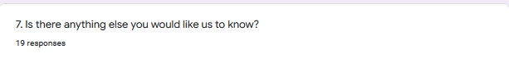

|  |  |
| --- | --- |
| ID# | 7. Is there anything else you would like us to know? |
| 1 | Thank you for today! |
| 2 |  |
| 3 | Terrific meeting! Well prepared and carefully thought out. Thank you! |
| 4 | Much gratitude and many prayers coming your way. |
| 5 | How very grateful I am for all your loving service. Thank you |
| 6 |  |
| 7 | I appreciate all that you do very much. |
| 8 | Thank you. |
| 9 | Information on the living out of our Carmelite Charism in our Carmels |
| 10 |  |
| 11 |  |
| 12 |  |
| 13 |  |
| 14 |  |
| 15 |  |
| 16 | How grateful I am for each of you. |
| 18 | Thank you for all your good work and service to CCA! |
| 19 | The reason I thought we might postpone another of these sessions is because we already have two other zoom tracks with Woman at the well and the sharing on the Synod. It is kind of hard to have time for all three. With the general assembly next year, we may not need to do these zoom meetings as much as we did when all the lockdowns were in place and they were kind of taking the place of our general assembly. |
| 20 | You're wonderful! Thank you for your service and the love you have for CCA. |
| 21 | thanks to you all for your service and love |
| 22 | just - THANK YOU! |
| 23 |  |
| 24 | Again and again thanks for all your work |
| 25 |  |
| 26 | I truly appreciate all your time, your planning and your love! |
| 27 | Thank you for your work for CCA! |
| 28 |  |
| 29 | Just how much we appreciate all the work entailed for each of you in CCA leadership. |
| 30 |  |
| 31 | Not a long reflection or prayer but some way to end our meeting together, rather than just leaving. |
| 32 |  |
| 33 | I'm just grateful for all that you do - you are all learning as you go and doing impressively well! Thank you! |